January 29, 2025

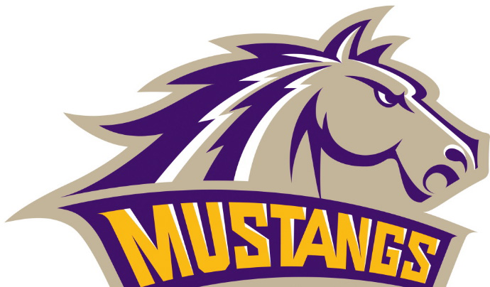As an employer sponsoring a group health plan, we provide Form 1095-C for full-time employees. Form 1095-C is an informational document used to help administer certain provisions of the Affordable Care Act (ACA). You do **NOT** need the form to file your tax returns. For more information, please visit the Internal Revenue Service’s Q & A Site.

You will no longer automatically receive the 1095-C Form; you may request the form by contacting us using any of the following methods of contact:

* Phone: 641-498-7481
* Email: [afrost@e-marshall.k12.ia.us](mailto:afrost@e-marshall.k12.ia.us)
* Mail: PO Box 159, Gilman, IA 50106